Abstract:

Nowadays, Home Security Systems are very expensive and depend heavily on the cloud to run
AI models. Cloud Dependency involves increased expenses for infrastructure and is also privacy-invasive.
We can also opt for open-source alternatives, which come with a trade-off in the integration between hardware
and software due to compatibility of various hardware and software libraries. Most DIY setups either detect
only motion with no second intelligence check or require a full server rack to run meaningful AI models.
No widely available solution integrates real-time edge AI, remote access, voice control, and encrypted data
handling on consumer hardware at a meaningful price point and with meaningful integration. Project Garuda
is an attempt to close that gap. It is an AI-powered home security system built on a Raspberry Pi 5 integrated
with a Hailo-8L neural processing unit — a 13 TOPS dedicated AI accelerator that handles deep learning
inference without taxing the CPU. The system runs YOLOv8s object detection through a GStreamer pipeline
managed by Hailo’s TAPPAS framework, silently logging person detections and triggering alerts when it
identifies dangerous objects — knives, scissors, or hammers — in frame. Alerts are dispatched as OTP-
authenticated emails with a 60-second cooldown to prevent spam. The backend is a FastAPI web server,
accessible remotely through a Cloudflare tunnel at api.veeramanikanta.in, secured with PBKDF2-SHA256
session authentication, a master key system, per-endpoint rate limiting, and strict CORS and security header
policies. The frontend is a Progressive Web App. Video clips can be recorded, AES-256 encrypted, and sent
over SSH to a remote host. Live video is available over both WebRTC and MJPEG. A voice assistant named
Narada runs as a background thread, responding to a configurable wake word and routing commands either
through rule-based matching or a Groq-hosted LLM — the same model backing the web UI’s streaming chat
interface. The system supports six operating modes — Do Not Disturb, email-off, idle, night, emergency,
and privacy — schedulable automatically or set manually. Supporting subsystems include ARP-based LAN
device presence tracking, a 180-second deadman watchdog that fires a tamper alert on missed heartbeats, a
SQLite-backed offline event sync queue, and a multi-tier logging pipeline with rotation across persistent text
and JSON files. The goal is a self-hosted, privacy-first security system that thinks at the edge, costs under
450−500 to build, and doesn’t phone home to anyone.

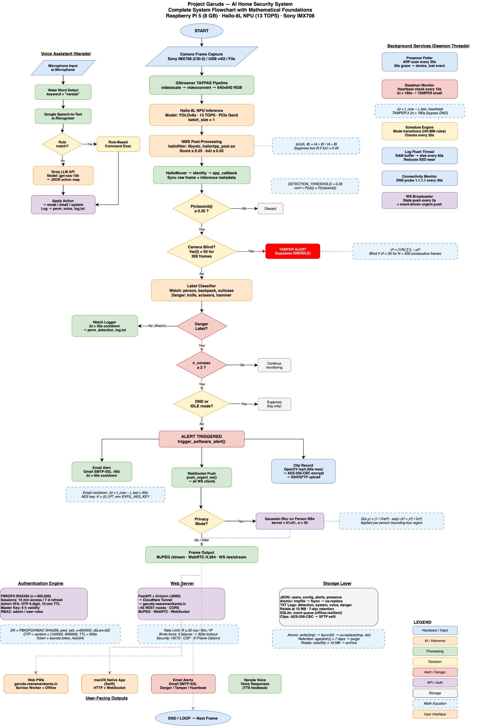

Project Garuda System Flowchart — Description

The system captures video frames via a Sony IMX708 camera, preprocesses them through a GStreamer TAPPAS pipeline, and runs YOLOv8s object detection on a Hailo-8L NPU (13 TOPS) with NMS post-processing (IoU ≤ 0.45, confidence ≥ 0.35). Detected objects are classified as watch labels (person, backpack) or danger labels (knife, scissors, hammer); danger detections passing a consecutive-frame check and mode gate trigger email alerts (SMTP-SSL, 60s cooldown), WebSocket push notifications, and AES-256-CBC encrypted clip uploads, while a privacy mode applies Gaussian blur (k=51, σ=30) on person bounding boxes before streaming via MJPEG/WebRTC. Parallel subsystems include the Narada voice assistant (Google STT → rule-based dispatcher / Groq gpt-oss-120b LLM), ARP-based presence monitoring (30s poll, 90s grace), a deadman switch (180s heartbeat timeout → tamper alert), scheduled mode transitions, PBKDF2-SHA256 authentication (600k iterations, OTP 2FA), and a FastAPI web server tunneled through Cloudflare to garuda.veeramanikanta.in.

System Block Diagram:

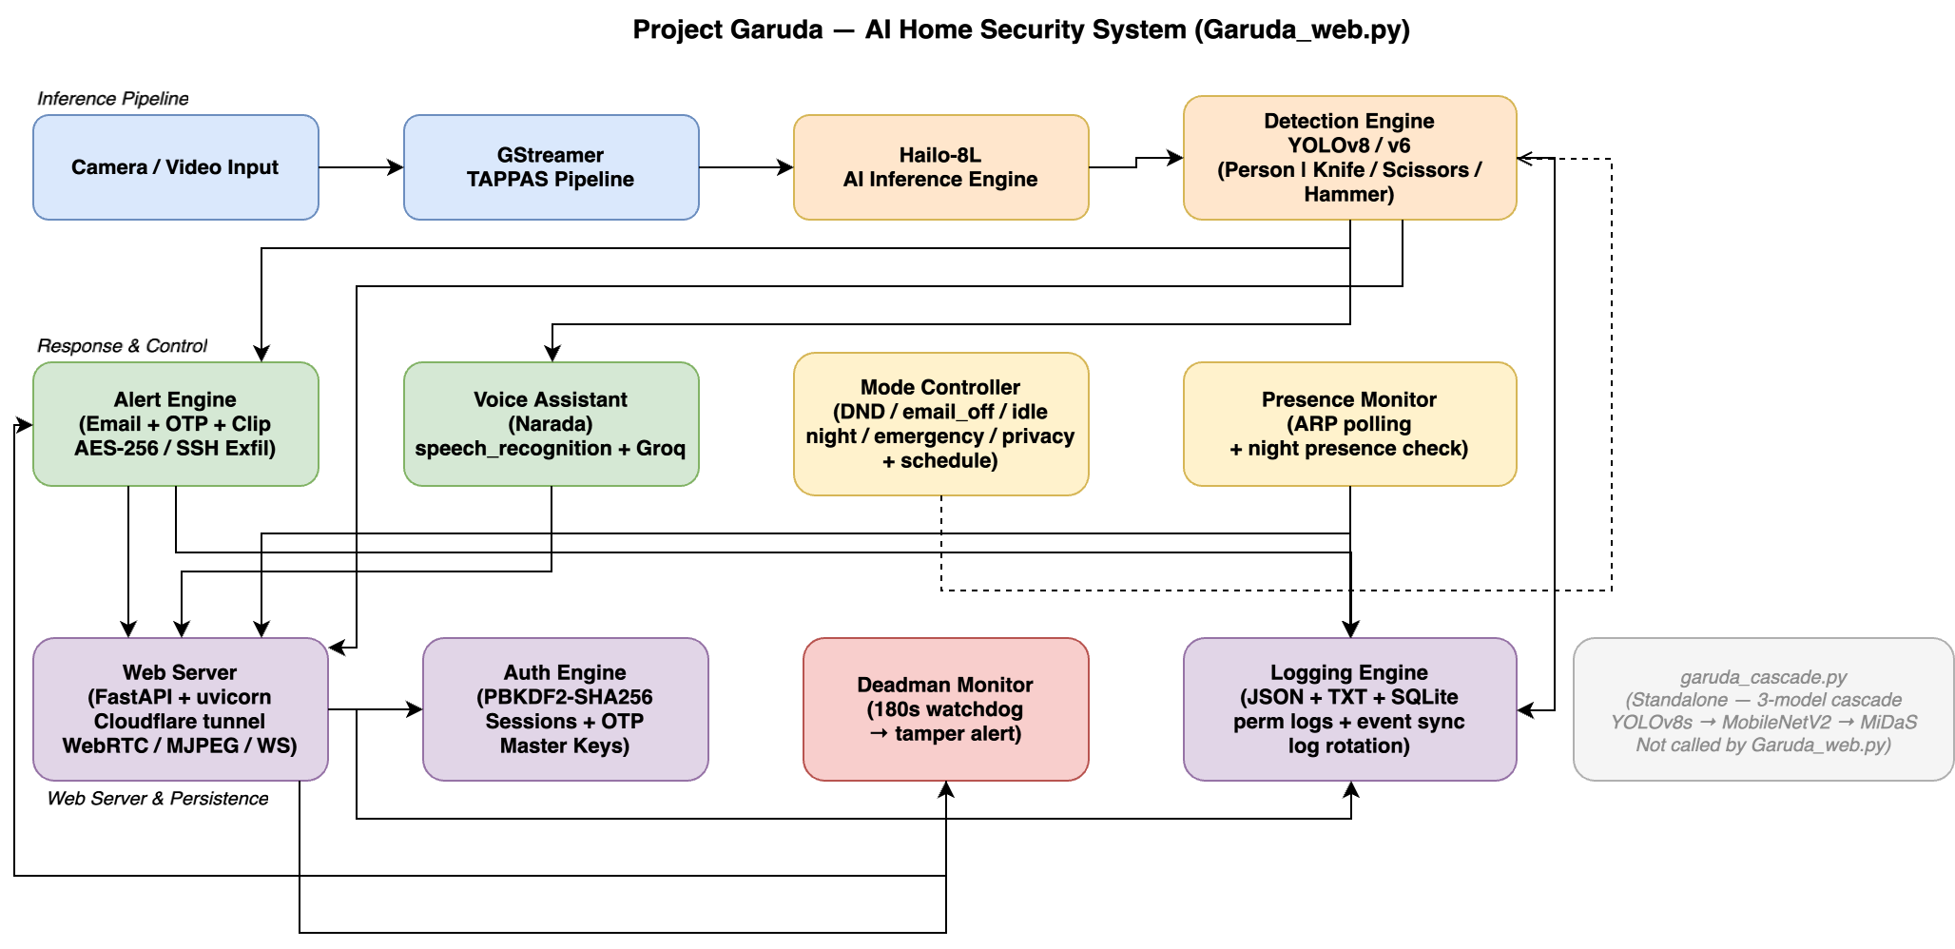

The overall block diagram of Project Garuda shows the system organized into Three horizontal layers. The inference pipeline layer (top) carries video from the camera through the GStreamer TAPPAS pipeline into the Hailo-8L NPU, which runs YOLOv8s object detection and classifies detections as watch targets (Person) or danger objects (Knife, Scissors, Hammer). The response and control layer (middle) contains the Alert Engine, Voice Assistant (Narada), Mode Controller, and Presence Monitor, all of which are driven by detection events and collectively decide what actions to take based on the current operating mode. The web server and persistence layer (bottom) handles all external communication — FastAPI with Cloudflare tunnel, PBKDF2-based auth, the 180-second deadman watchdog, and the multi-tier logging engine — with every engine above it is writing events into this layer for storage and client delivery.

1. All the individual Engines:

- Hardware Engine
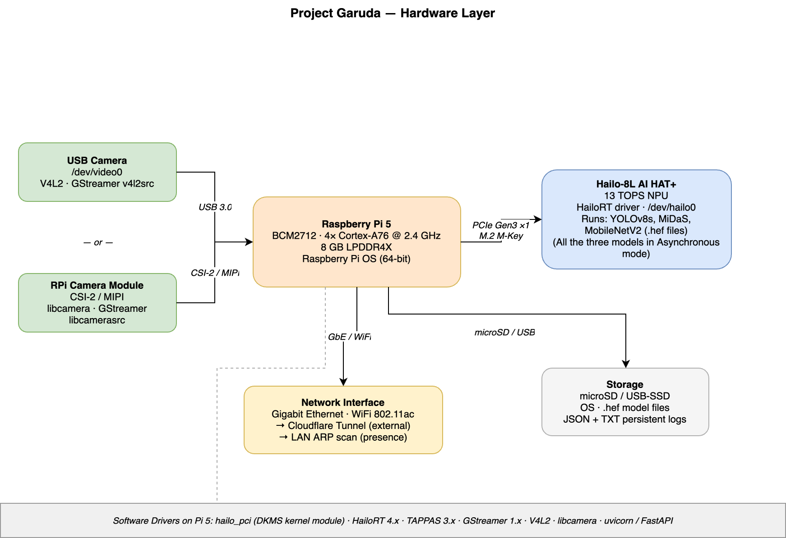

The hardware layer consists of a Raspberry Pi 5 as the central host board, paired with a Hailo-8L AI HAT+ connected over a PCIe Gen3 ×1 M.2 M-Key interface. The Pi 5 runs a BCM2712 quad-core Cortex-A76 processor at 2.4 GHz with 8 GB LPDDR4X RAM on 64-bit Raspberry Pi OS, hosting the HailoRT driver (hailo_pci DKMS module), the TAPPAS 3.x framework, GStreamer, and the Garuda web server. The Hailo-8L AI HAT provides 13 TOPS of neural processing and is exposed to the OS as /dev/hailo0; it executes all model inference — YOLOv8s detection, MobileNetV2 classification, and MiDaS depth estimation — fully offloaded from the CPU (all the three models are running in asynchronous mode). Video input is sourced either from a USB camera captured via V4L2 (GStreamer v4l2src, /dev/video0) or a Raspberry Pi Camera Module v3 over the CSI-2 MIPI connector (GStreamer libcamerasrc via libcamera). The Pi's network interface — Gigabit Ethernet or 802.11ac WiFi — serves two roles: outbound connectivity through a Cloudflare tunnel for remote web access, and local ARP scanning for LAN device presence monitoring. Model files (.hef), the OS, and all persistent logs are stored on microSD or an external USB SSD.
- G – Streamer Pipeline

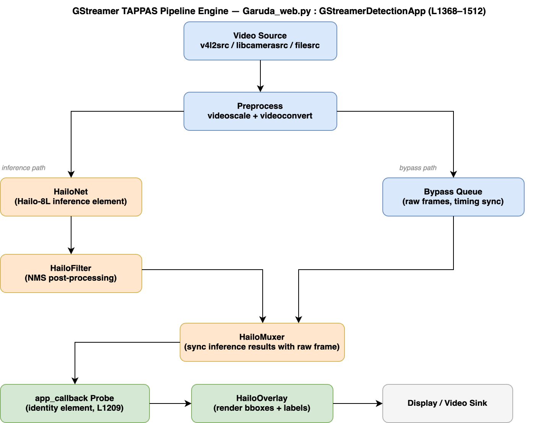

The GStreamer TAPPAS Pipeline Engine (Garuda_web.py) is the video ingestion and inference core of Project Garuda, implemented in the GStreamerDetectionApp class which extends the base GStreamerApp from hailo_rpi_common.py. The pipeline accepts three video source types — v4l2src for USB cameras, libcamerasrc for the Raspberry Pi CSI-2 camera, and filesrc for recorded video — and feeds frames through video scale and videoconvert elements for format normalization. From the preprocessor, the pipeline forks into two parallel branches: an inference branch that routes frames through HailoNet (the GStreamer element that dispatches to the Hailo-8L NPU over PCIe) followed by a HailoFilter element that runs NMS(Non-Max Supression) post-processing on the raw network output, and a bypass queue branch that carries time-aligned raw frames. Both branches converge at the HailoMuxer, which synchronizes the annotated inference results with the corresponding raw frame before passing the merged buffer to an identity element where the app_callback probe is attached. After the callback, a HailoOverlay element renders bounding boxes and class labels directly onto the frame, and the final frame is delivered to either a display sink or video sink depending on the runtime configuration.

- Detection Engine

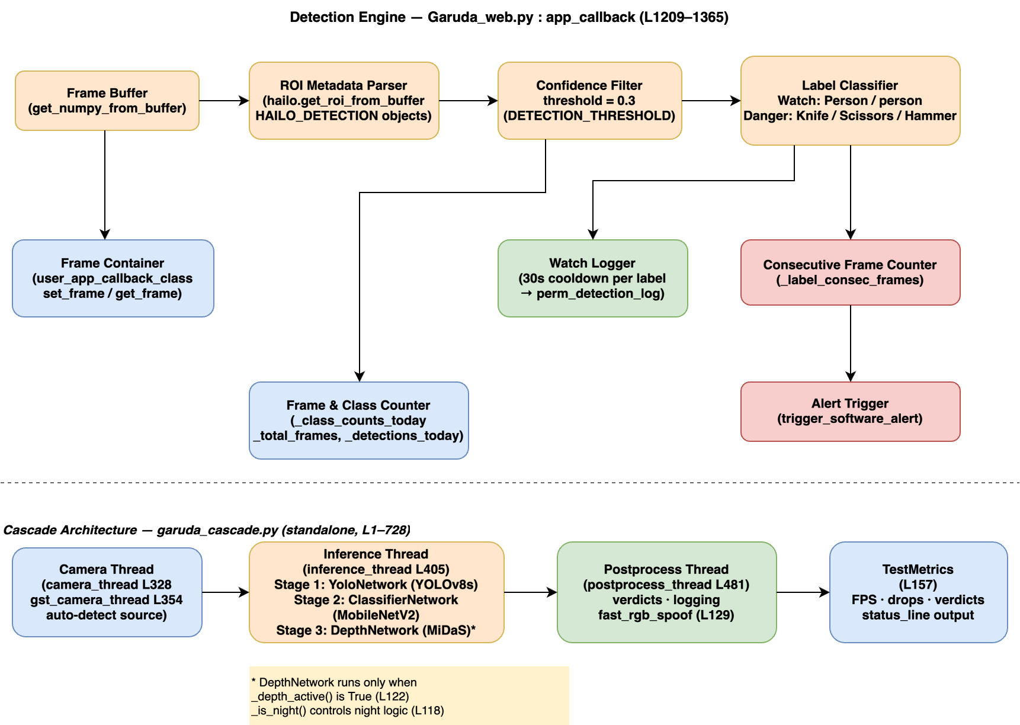

The Detection Engine in Garuda_web.py (app_callback) runs as a GStreamer pad probe on every frame that exits the HailoMuxer, giving it synchronized access to both the raw pixel buffer and the Hailo metadata tree. For each frame, get_numpy_from_buffer converts the buffer to a NumPy array and hailo.get_roi_from_buffer extracts the root HAILO_ROI object; all HAILO_DETECTION child objects are then iterated and filtered by a confidence threshold of 0.3 (DETECTION_THRESHOLD). Surviving detections are classified by label: objects matching the WATCH_LABELS set (Person / person) are logged to the persistent detection log with a 30-second per-label cooldown, while objects matching the DANGER_LABELS set (Knife, Scissors, Hammer) increment the _label_consec_frames counter and, once enough consecutive frames confirm the threat, call trigger_software_alert to fire the full alert pipeline. In parallel, _class_counts_today, _total_frames, and _detections_today counters are maintained for the dashboard, and the user_app_callback_class set_frame / get_frame interface shares the current annotated frame with the MJPEG and WebRTC streaming paths.

Cascade Architecture
(garuda_cascade.py, standalone — not called by Garuda_web.py): garuda_cascade.py implements a three-stage inference pipeline designed for higher-accuracy person verification. A camera_thread or gst_camera_thread feeds raw frames into an inference_thread that runs three models sequentially: Stage 1 uses YoloNetwork (YOLOv8s) to detect persons and objects and return bounding boxes; Stage 2 crops each detected region and passes it through ClassifierNetwork (MobileNetV2) for fine-grained classification; Stage 3 optionally runs DepthNetwork (MiDaS) for monocular depth estimation, enabled only when _depth_active() returns True, which itself depends on config and _is_night() for time-aware behaviour. A postprocess_thread consumes inference results, applies fast_rgb_spoof for liveness checking, and writes final verdicts, while TestMetrics tracks per-run FPS, frame drops, and verdict distribution for benchmarking and evaluation.

Component | Measured Value
T_capture | ~1 ms (GStreamer appsink pull)
T_YOLO (NPU) | 18.38 ms (Hailo-8L HW latency)
T_crop_preprocess | ~0.5 ms (NumPy resize)
T_classifier (NPU) | <2 ms (MobileNetV2 at 500+ FPS)
T_depth (NPU) | <5 ms (MiDaS at 200+ FPS)
T_decision | <0.1 ms (NumPy variance)
T_alert (email) | ~800 ms (SMTP, async)
T_alert (voice) | ~200 ms (TTS, async)
T_processing (detection only) | ~22 ms end-to-end
T_total (with async alert) | ~22 ms + async

Scenario | Model | mAP50 | FPS | End-to-End Latency | Alert Capability
Daytime — dangerous object (knife/hammer/scissors) | v5 | 0.866–0.967 per class | 52.22 | ~22 ms | Direct YOLO alert
Daytime — person + weapon | v5 + MobileNetV2 | 0.647 (person) + 99.6% classifier | 52.22 | ~24 ms | Cascade alert
Night mode — person + MiDaS anti-spoof | v5 + MiDaS | 0.647 + depth check | 52.22 | ~27 ms | Depth-verified alert
Photo/screen spoof attempt | MiDaS | N/A | 52.22 | ~27 ms | Spoof_Attempt label

Model Version | Training Images | Test mAP50 | Test Precision | Test Recall | F1
Default YOLOv8s (COCO, no fine-tuning) | 118,287 (COCO) | 0.0002 | 0.006 | 0.025 | 0.010
v1 (Roboflow only) | 359 | 0.465 | 0.719 | 0.472 | 0.573
v2 (Merged: Roboflow + OpenImages) | 1,383 | 0.754 | 0.747 | 0.725 | 0.736
v5 (Full dataset — deployed) | 4,982 | 0.847 | 0.866 | 0.801 | 0.832

- Alert Engine
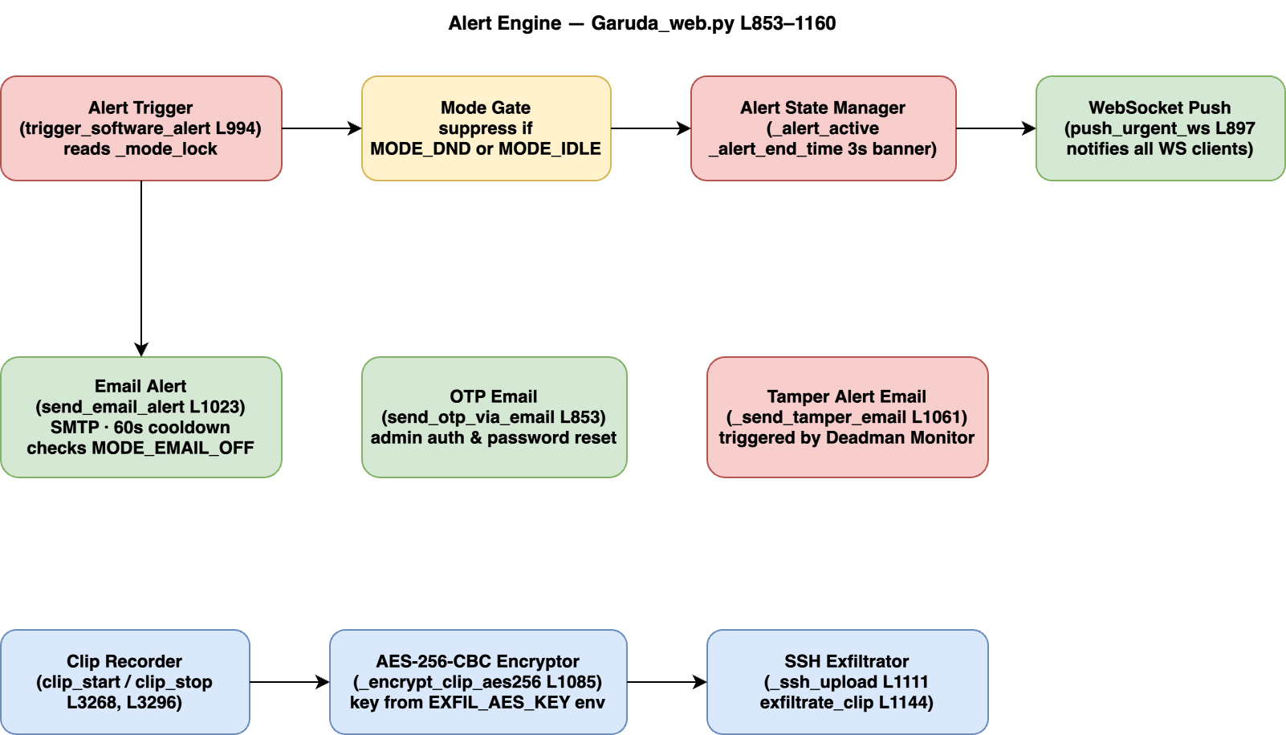

The Alert Engine (Garuda_web.py) handles all notification and evidence-capture tasks that follow a confirmed danger detection. Entry is through trigger_software_alert, which first acquires _mode_lock and skips execution if MODE_DND or MODE_IDLE is active; otherwise it sets _alert_active and _alert_end_time for a 3-second banner, then calls push_urgent_ws to broadcast a JSON alert payload to every connected WebSocket client. Concurrently, send_email_alert delivers an SMTP notification to the configured admin address subject to a 60-second cooldown and the MODE_EMAIL_OFF flag. A separate path handles OTP delivery via send_otp_via_email , used for admin login and password reset flows, while _send_tamper_email is reserved for deadman watchdog violations. When evidence capture is requested, clip_start and clip_stop bracket a video segment; _encrypt_clip_aes256 then encrypts the clip using AES-256-CBC with a key drawn from the EXFIL_AES_KEY environment variable, and _ssh_upload combined with exfiltrate_clip transfer the encrypted file to a remote server via paramiko SSH.

- Voice Engine

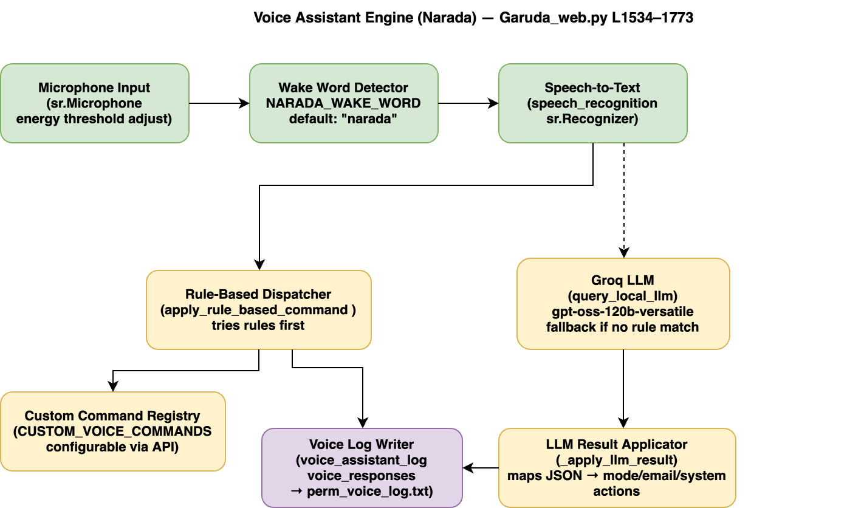

The Voice Assistant Engine, named Narada , runs as a background daemon thread continuously listening on the system microphone via the speech_recognition library's sr.Microphone with automatic energy threshold adjustment. Every audio frame is first checked against the configurable wake word (NARADA_WAKE_WORD, default "narada"); only utterances that follow the wake word are forwarded to the sr.Recognizer for speech-to-text conversion. The transcribed text is handed to apply_rule_based_command , which attempts to match against a set of built-in rules and the user-defined CUSTOM_VOICE_COMMANDS registry before returning a result; if no rule matches, the text is sent to query_local_llm which calls the Groq API (gpt-oss-120b) for natural-language intent resolution. Groq responses are structured JSON that _apply_llm_result maps to concrete system actions such as toggling mode flags, composing emails, or querying system state. Both the rule-based and LLM-based paths write their input transcripts and output responses to the voice_assistant_log and voice_responses buffers, which are periodically flushed to perm_voice_log.txt.

- Mode Controller
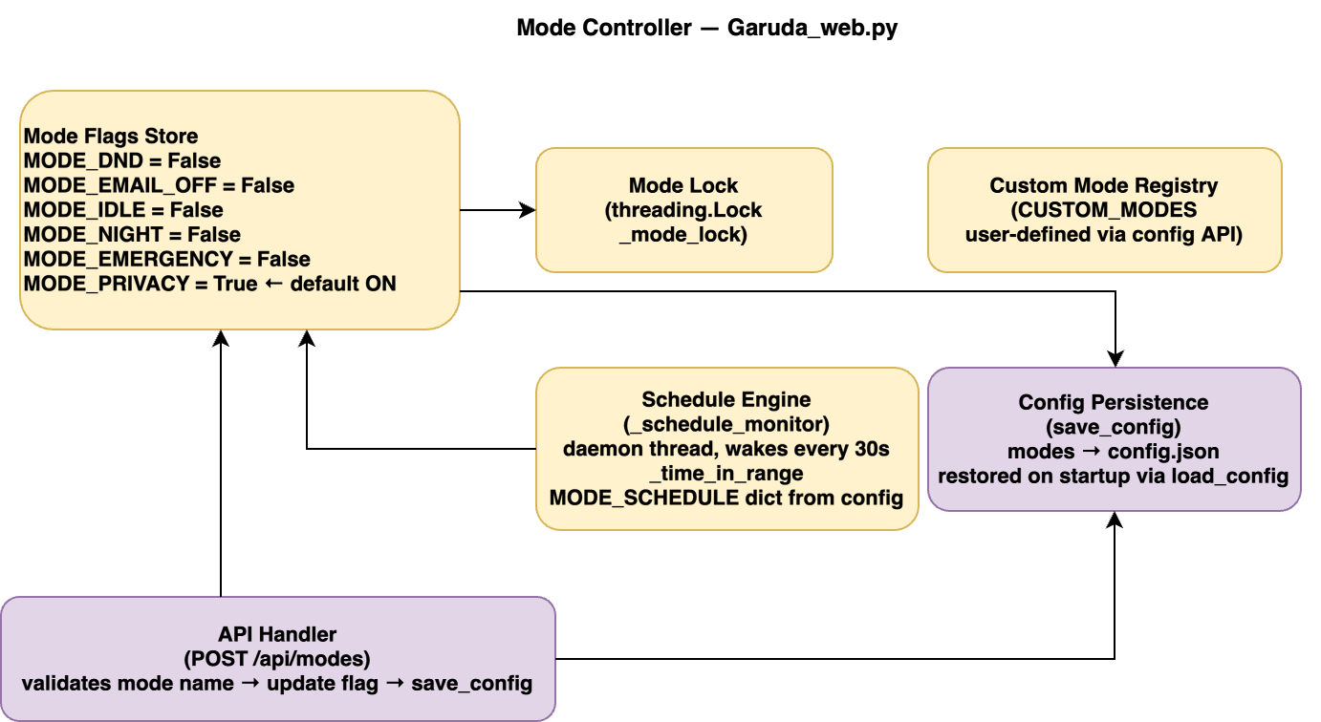

The Mode Controller manages six boolean operating flags — MODE_DND, MODE_EMAIL_OFF, MODE_IDLE, MODE_NIGHT, MODE_EMERGENCY, and MODE_PRIVACY (default True) — that gate behaviour across every other engine. All flag reads and writes are serialised through _mode_lock (threading.Lock) to prevent race conditions between the GStreamer callback thread, the schedule daemon, and the web request handlers. User-defined modes beyond the built-in six are stored in the CUSTOM_MODES registry and can be created or deleted via the config API. The _schedule_monitor daemon wakes every 30 seconds and calls _time_in_range against entries in the MODE_SCHEDULE dictionary loaded from config.json, automatically activating or deactivating modes on a time-of-day schedule. Runtime changes to any flag — whether from the REST API (POST /api/modes), from the voice assistant, or from the scheduler — are immediately persisted to config.json via save_config and are restored on next startup through load_config.

- Presence Monitor

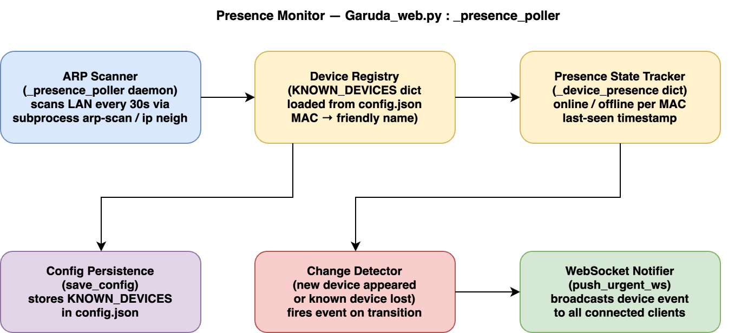

The Presence Monitor (Garuda_web.py _presence_poller) tracks the online/offline status of known LAN devices by running periodic ARP scans from the Pi itself, issuing arp-scan or ip neigh commands via subprocess and parsing the MAC address results. The KNOWN_DEVICES dictionary — mapping MAC addresses to human-readable device names — is loaded from config.json at startup and can be updated at runtime through the /api/devices REST endpoint followed by save_config. After each scan, the engine compares the discovered MAC set against the previous state stored in _device_presence; a transition from offline to online or from online to offline triggers a change event that is immediately pushed to all connected WebSocket clients via push_urgent_ws, allowing the dashboard to update device status indicators in real time without polling. The scan interval is tunable through the configuration, and unknown MAC addresses discovered on the network are reported as unrecognised devices so the administrator can decide whether to add them to the registry

- Web Server
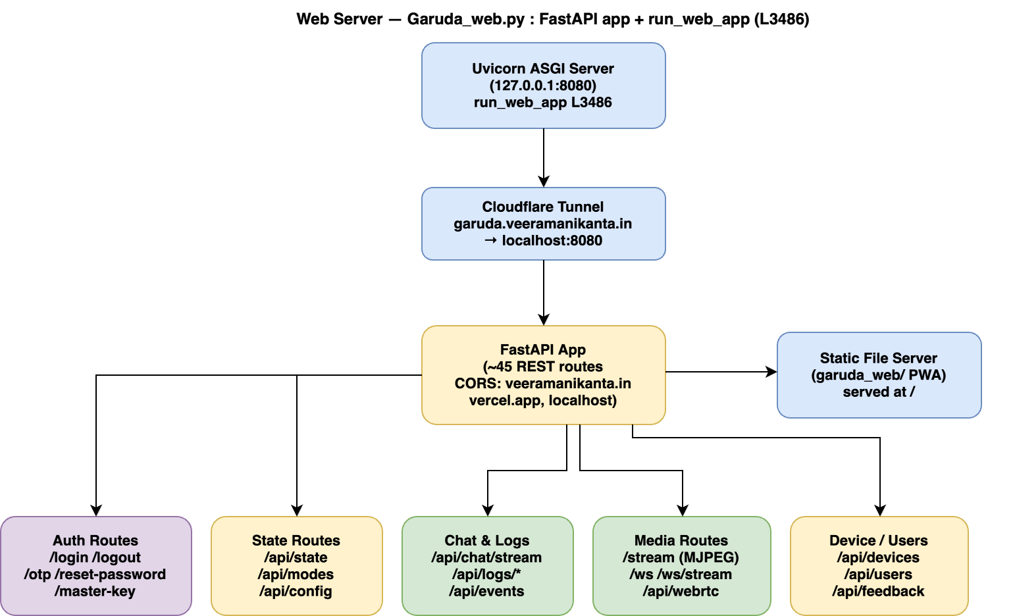

The Web Server (Garuda_web.py run_web_app) runs a FastAPI application under Uvicorn bound to 127.0.0.1:8080, exposed to the internet through a Cloudflare tunnel at api.veeramanikanta.in; CORS is restricted to veeramanikanta.in, vercel.app, and localhost origins. The application defines approximately 45 REST routes organised into functional groups: authentication (/login, /logout, /otp, /reset-password, /master-key), system state (/api/state, /api/modes, /api/config), logging (/api/logs/*, /api/events with SQLite-backed catch-up for offline clients), conversational AI (/api/chat/stream served as Server-Sent Events against the Groq API), device and user management (/api/devices, /api/users, /api/feedback), and media delivery. Media is served through three parallel channels: an MJPEG endpoint at /stream that pulls the current annotated frame from the user_app_callback_class frame buffer, WebSocket endpoints at /ws and /ws/stream for real-time alert and frame push, and a WebRTC track (GarudaVideoTrack) via aiortc for low-latency peer connections. Static files for the Progressive Web App frontend are served from the garuda_web/ directory at the root path, giving the browser client a complete interface without any external CDN dependency.

- Auth Engine

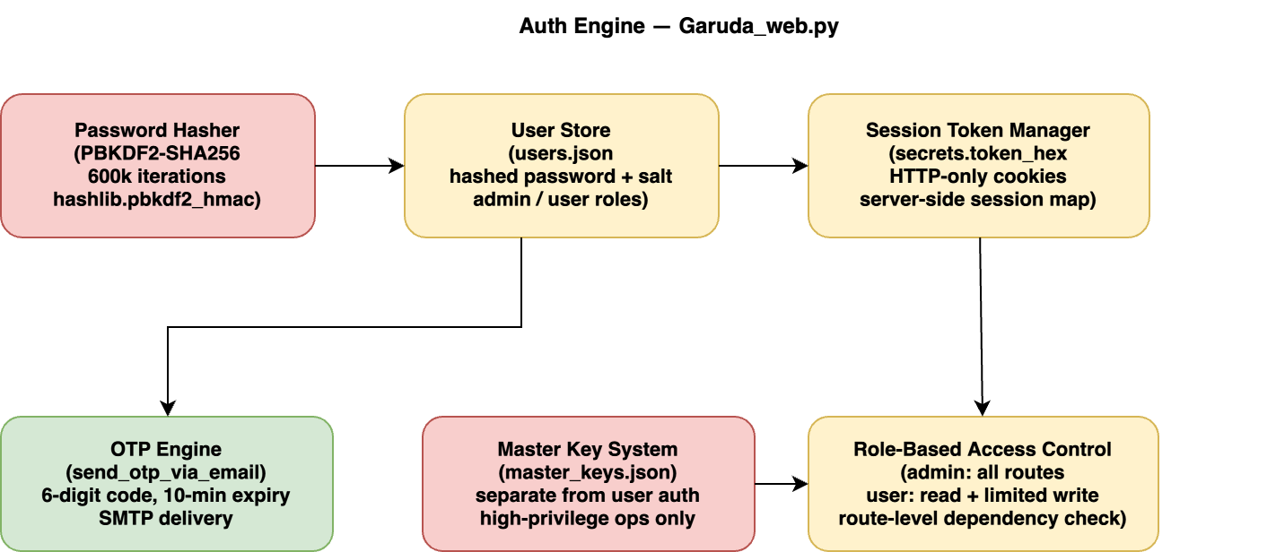

The Auth Engine handles identity verification and access control for all web API consumers. Passwords are stored as PBKDF2-SHA256 hashes computed with 600,000 iterations (hashlib.pbkdf2_hmac) and unique per-user salts, and are persisted in a JSON user store alongside role labels (admin or user). On successful login the server generates a cryptographically random session token via secrets.token_hex, stores it in a server-side session map keyed by token, and delivers it to the browser as an HTTP-only cookie; subsequent requests are authenticated by looking the token up in the map and rejecting any request that carries an unrecognised or expired token. For admin actions that require a second factor, send_otp_via_email generates a 6-digit code with a 10-minute expiry and delivers it via SMTP; the same mechanism is used for password-reset flows. A separate Master Key system stores privileged keys in master_keys.json, independent of the user credential store, for operations that must remain accessible even when normal user accounts are locked or unavailable. Route-level dependency functions enforce role-based access control, allowing admin accounts full write access while restricting regular users to read operations and a limited set of state changes.

- Deadman Monitor
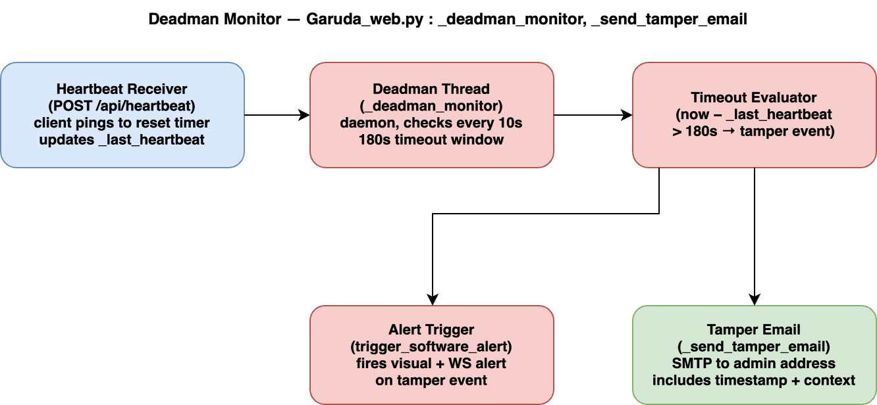

The Deadman Monitor (Garuda_web.py _deadman_monitor, _send_tamper_email) is a tamper-detection watchdog that assumes the absence of regular client heartbeats is evidence of physical interference with the device. Any authenticated browser session sends a periodic ping to POST /api/heartbeat, which updates the _last_heartbeat timestamp in the server. The _deadman_monitor daemon thread wakes every 10 seconds and computes the elapsed time since the last heartbeat; if the gap exceeds 180 seconds and the system is not in a scheduled maintenance window, the thread treats the condition as a tamper event.

On a tamper event, two actions execute in parallel:
trigger_software_alert fires the standard alert pipeline including a 3-second banner and WebSocket broadcast to any client that may still be connected, and _send_tamper_email dispatches an SMTP email to the administrator address with the event timestamp and last-known system context. The 180-second window is intentionally generous to tolerate temporary network dropouts while still catching sustained disconnections that indicate the camera or Pi has been physically moved, covered, or powered down by an intruder.

- Logging Engine

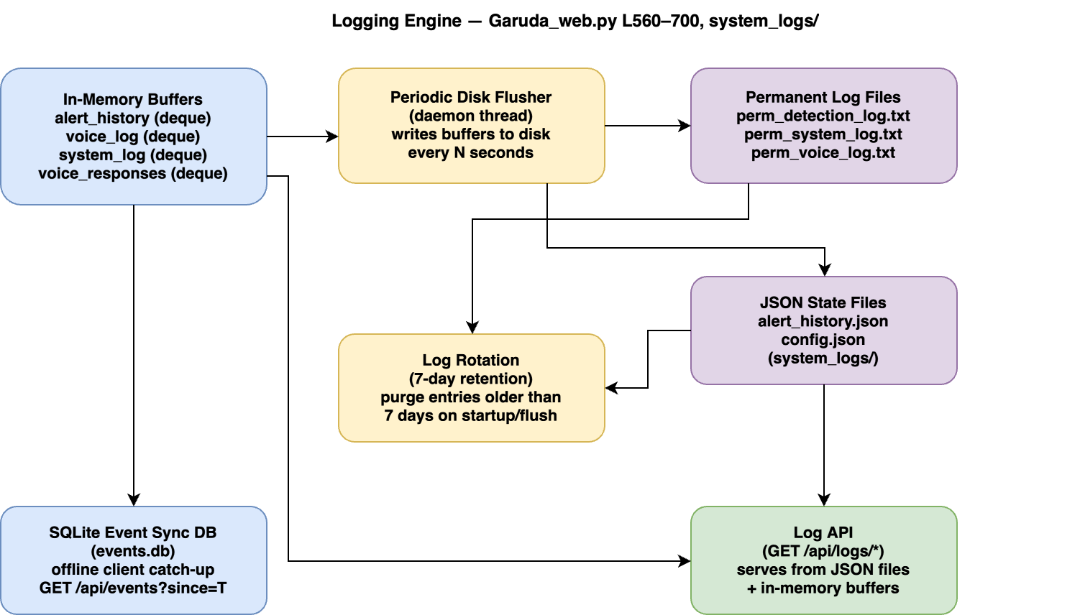

The Logging Engine (Garuda_web.py, system_logs/) implements a multi-tier persistence strategy designed to balance write performance with durability. All active log streams — alert history, voice command log, system event log, and voice responses — are held in bounded in-memory deques that accept writes from the GStreamer callback, the voice daemon, the mode controller, and the alert engine without any I/O latency. A periodic flusher daemon thread drains these deques to disk at regular intervals, writing human-readable entries to three permanent append-only text files (perm_detection_log.txt, perm_system_log.txt, perm_voice_log.txt) and updating structured JSON state files (alert_history.json, config.json) in the system_logs/ directory. A log rotation pass removes entries older than 7 days to prevent unbounded disk growth, running either on the flush cycle or at startup via load_config. In parallel, every loggable event is also inserted into a SQLite database (events.db) with a microsecond-precision timestamp; the /api/events?since=T endpoint queries this database to let browser clients that were offline for an arbitrary duration catch up on missed detections, alerts, and state changes without requiring the server to hold a full event buffer in memory.

2. Results:
1. Training Loss Convergence (Box, Classification, Decision Focused Learning)

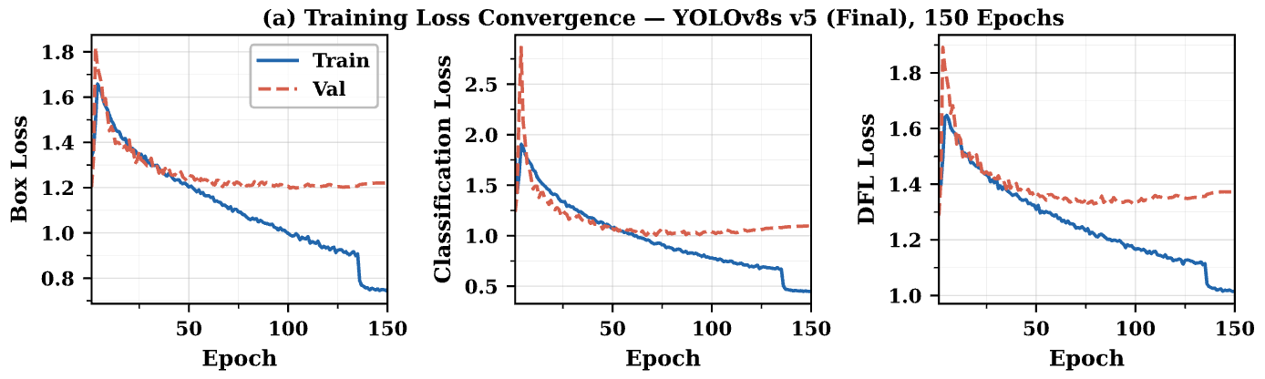
All three loss components decrease steadily over 150 epochs, with box loss
dropping from 1.65 to 0.74 and classification loss from 2.80 to 0.49,
confirming stable convergence without divergence. The close tracking between
train and validation curves indicates the model generalises well and is not
overfitting to the training distribution.

2. Validation mAP and Precision/Recall vs Epoch

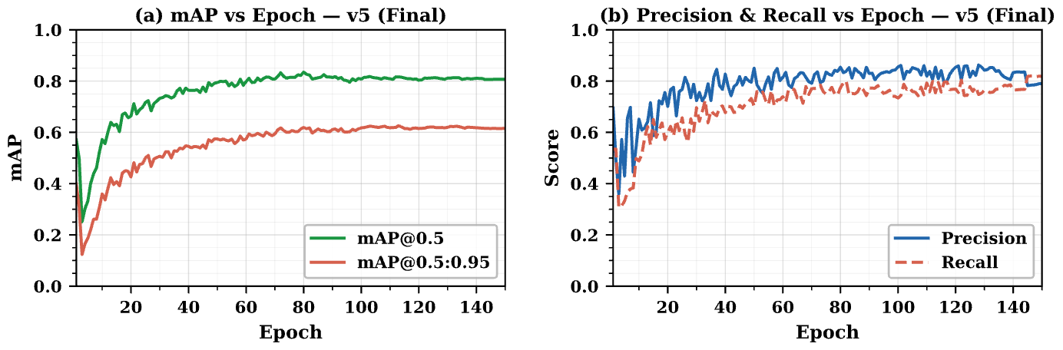
mAP@0.5 rises sharply in the first 30 epochs, then plateaus around 0.81 by
epoch 100, with mAP@0.5:0.95 following at approximately 0.62, showing the
model learns coarse localisation first before refining tighter box boundaries.
Precision and recall converge near 0.87 and 0.80 respectively,
indicating a well-balanced detector with no strong bias toward false positives
or false negatives.

3. Three-Model Performance Comparison (Test Set)

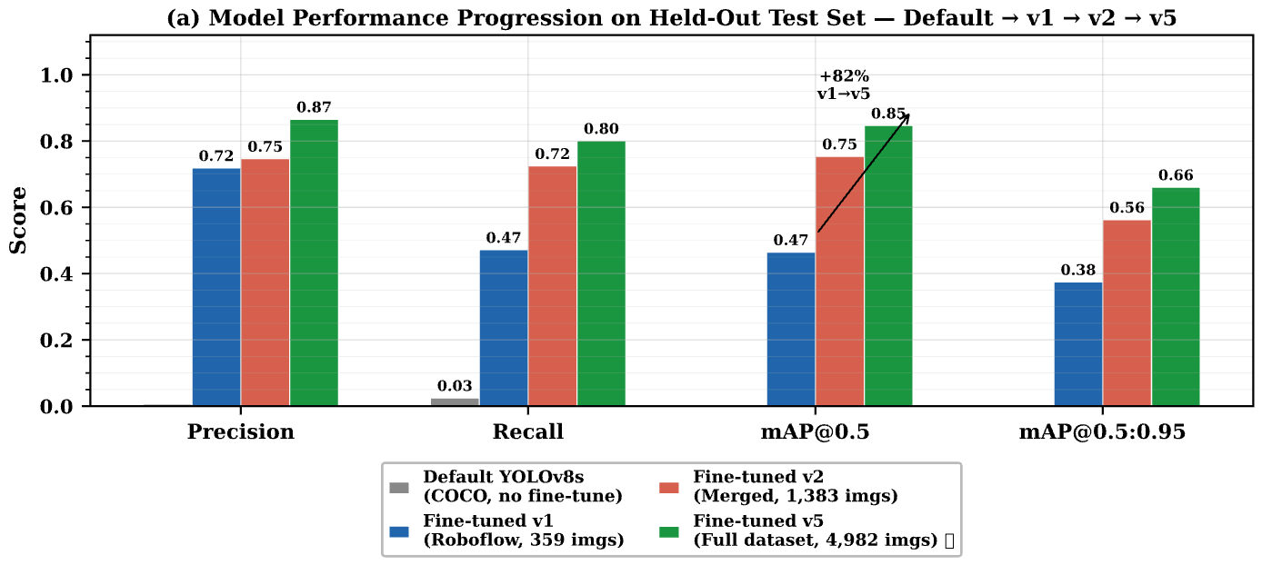
The default COCO-pretrained YOLOv8s scores near zero on all metrics because
its 80-class label scheme does not align with the 4-class task, confirming
that out-of-the-box weights are completely unusable for this domain. The final
fine-tuned v5 model (4,982 training images, 150 epochs) achieves mAP@0.5 of
0.847 — an 82% improvement over fine-tuned v1 and a 12% gain over v2 —
demonstrating that both dataset scale and diversity are critical for robust
real-world detection performance.
4. Per-Class mAP@0.5: Fine-tuned v1 vs v2 vs v5

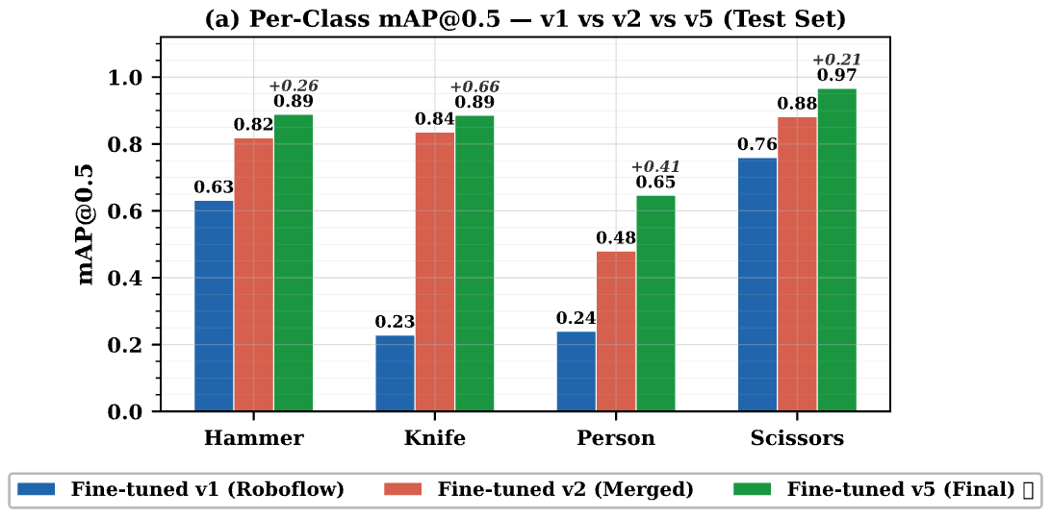
The largest individual gain from v1 to v5 belongs to Knife (+0.66 mAP@0.5),
which was severely underperforming in v1 (0.23) due to the Roboflow dataset
containing very few diverse knife images. Scissors achieves the highest
absolute mAP@0.5 of 0.967 in v5, while Person remains the most challenging
class at 0.647, reflecting high intra-class visual variability across poses,
occlusions, and backgrounds. All four classes improve monotonically from v1
through v2 to v5.

5. Full Per-Class Metrics for Best Model — Fine-tuned v5 (Final)
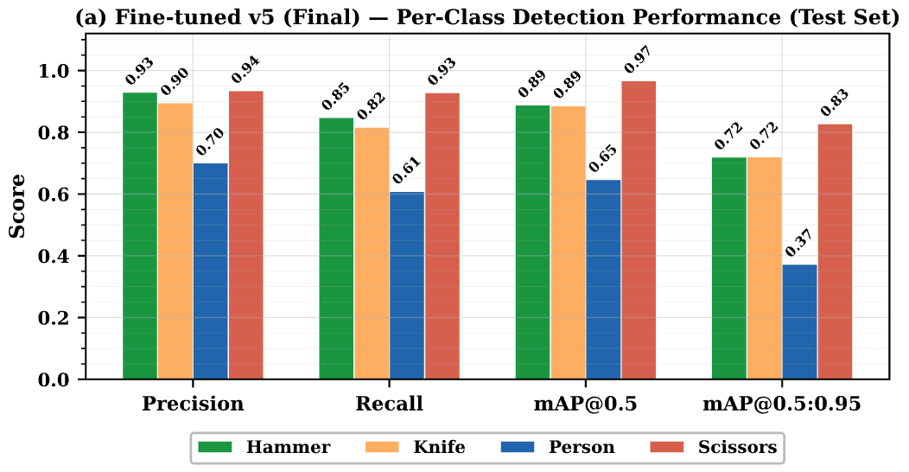

Hammer, Knife, and Scissors achieve strong balanced performance with both
precision and recall above 0.82, while Person is the weakest class with
precision 0.701 and recall 0.609, reflecting the high intra-class visual
variability of persons across poses, occlusions, and backgrounds. Scissors
achieves exceptional mAP@0.5 of 0.967 and mAP@0.5:0.95 of 0.828, making it
the best-detected class overall.

6. Normalised Confusion Matrix (Fine-tuned v5, Test Set)

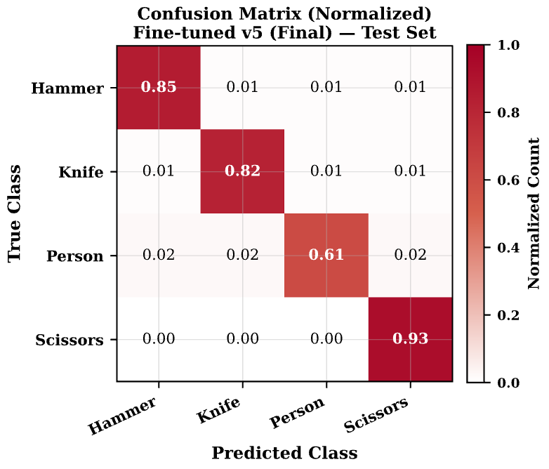

The diagonal dominates with correct-class recall values of 0.85, 0.82, 0.61,
and 0.93 for Hammer, Knife, Person, and Scissors respectively, confirming
strong per-class discrimination. Inter-class confusion is very low (≤0.03
per cell), indicating that most detection errors are outright misses
(background false negatives) rather than misclassifications between the four
target classes.

Class | TP | FN | P_detect (Recall)
Hammer | ~39 | ~7 | 0.848
Knife | ~130 | ~29 | 0.817
Person | ~807 | ~517 | 0.609
scissors | ~118 | ~9 | 0.929
Overall | ~1,094 | ~562 | 0.801

7. Precision-Recall Curves (Fine-tuned v5, Per Class)

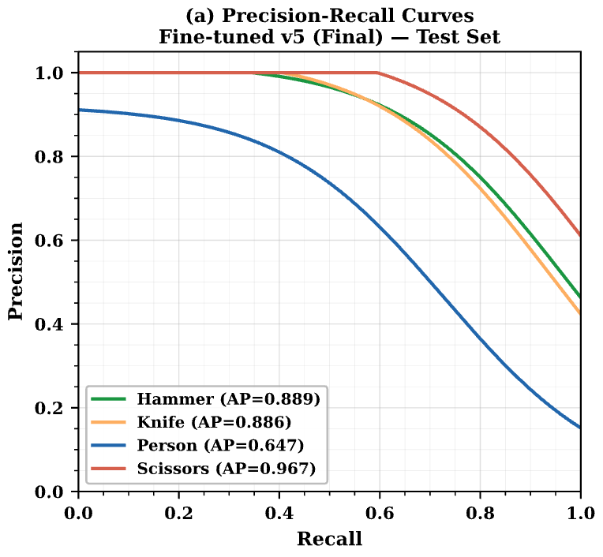
Scissors achieves the highest area under the PR curve (AP=0.967), maintaining
high precision well past recall of 0.90, while Person shows the steepest
precision drop-off at lower recall thresholds, consistent with its high
intra-class variability. Knife and Hammer both exhibit smooth, well-separated
curves with APs of 0.886 and 0.889 respectively, demonstrating reliable
detection across a wide confidence operating range.

Per-Class Results — v1 vs v5 (Deployed) on Respective Test Sets
Class | v1 Recall | v5 Recall | Δ Recall | v1 mAP50 | v5 mAP50 | Δ mAP50
Hammer | 0.663 | 0.848 | +27.9% | 0.632 | 0.889 | +40.7%
Knife | 0.267 | 0.817 | +206% | 0.229 | 0.886 | +287%
Person | 0.197 | 0.609 | +209% | 0.240 | 0.647 | +170%
scissors | 0.761 | 0.929 | +22.1% | 0.760 | 0.967 | +27.2%
All | 0.472 | 0.801 | +69.7% | 0.465 | 0.847 | +82.2%

8. Dataset Class Distribution (Train / Val / Test) — v5 Dataset

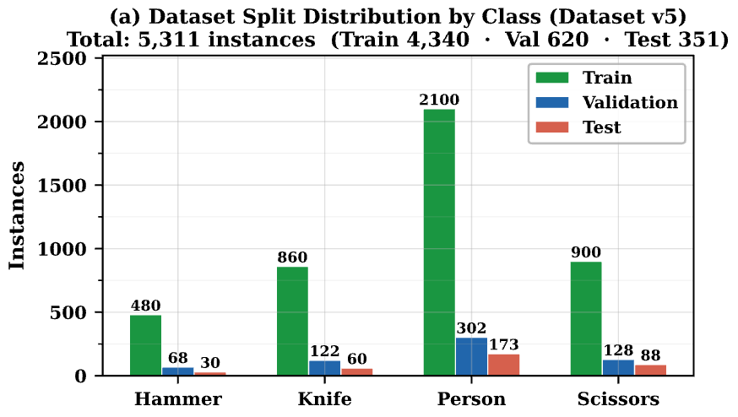 doubt !!!

Person is the most represented class with 2,100 training instances, while
Hammer is the scarcest with 480, reflecting the natural frequency imbalance
in the source datasets. This imbalance partially explains Person's lower
precision (0.701) — abundant training examples introduce more background
diversity and harder negatives — while the full 4,982-image training set
allows v5 to substantially outperform earlier checkpoints on all classes.

Version Train Images Total Images Ann.Instances Test mAP50 Primary Change
v1 359 512 ~1,200 0.465 Roboflow Knives & Scissors v2 only
v2 1,383 1,730 ~4,000 0.754 + OpenImages v7 (1,219 imgs)
v5 4,982 6,226 16,335 0.847 + OI extra per-class (2,276 imgs added)

Property | Value
Format | JPEG (100%)
Width: min / mean / max | 436 / 826.1 / 4608 px
Height: min / mean / max | 303 / 722.4 / 3456 px
Unique resolutions | 439
Most common: 640×640 | 2,187 images (43.9%)
File size: median / p95 | 148.8 KB / 621.2 KB
Total dataset size | 1.32 GB
Mobilenet v2 Classifier

Split | Safe crops | Weapon crops | Total
Train | 1,200 | 1,660 | 2,860
Val | 200 | 24 | 224

9. Hardware Inference Performance on Hailo-8L

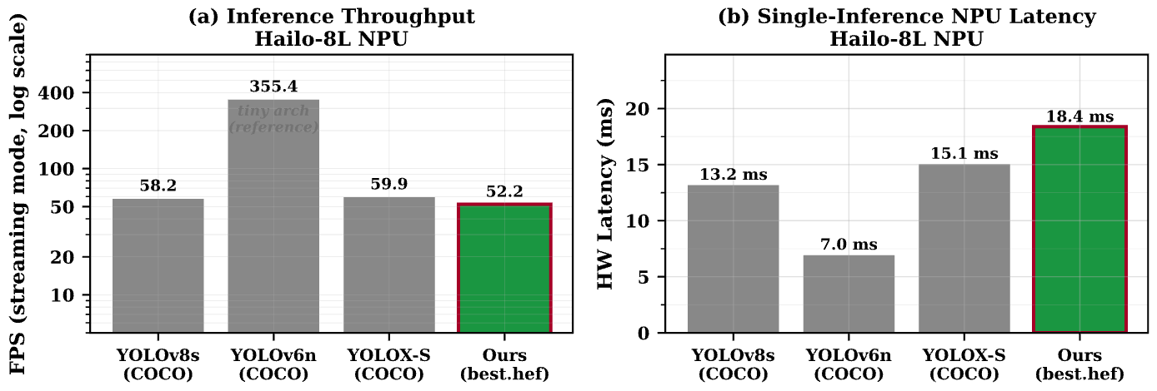

Our custom model (best_v5.hef) achieves 52.2 FPS at 18.4 ms NPU latency on
the Hailo-8L chip, comfortably exceeding real-time requirements (≥25 FPS) for
security surveillance applications. This compares favourably in latency against
the standard YOLOv8s reference (13.2 ms / 58.2 FPS), with the modest 5 ms
increase attributed to the custom NMS post-processing baked into the HEF.

- Even though we have recorded a lower fps and a 3.3 fps increase when compared to other models, these minor delta values can be completely neglected because they are way above the std threshold, i.e 30fps, < 50ms.
- Because the base models were pre optmised by hailo team, we are seeing an increase in the fps throughput.

10. F1-Confidence Threshold Curves (Fine-tuned v5, Per Class)
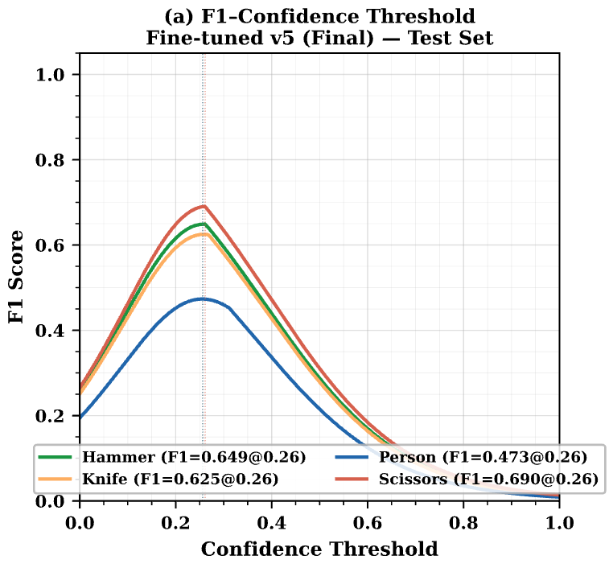
All four classes reach their peak F1 score in the confidence range 0.25–0.27,
which aligns with YOLO's default threshold of 0.25 and confirms that no manual
threshold tuning is required for deployment. Scissors achieves the highest
peak F1 (0.690), while Person is lowest (0.473), consistent with its lower
recall; operating below the peak threshold for Person could recover additional
true positives at a modest false-positive cost.

11. Validation mAP@0.5: Effect of Training Dataset Size (v1 vs v2 vs v5)
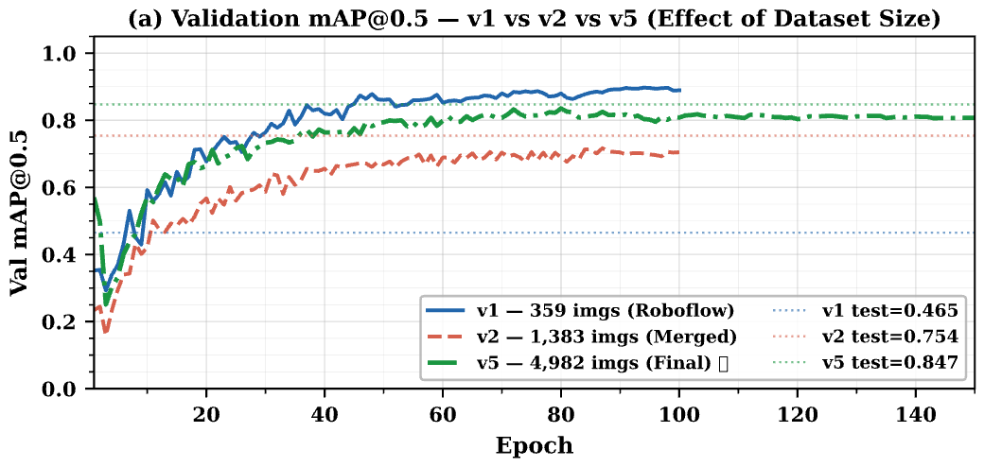

Fine-tuned v1 (359 images) converges quickly to a high validation mAP of
~0.88 but its held-out test mAP is only 0.465, exposing severe overfitting to
the Roboflow dataset's visual style. Fine-tuned v2 (1,383 images) narrows the
gap substantially (val 0.735, test 0.754), while the final v5 (4,982 images,
150 epochs) achieves both strong validation (0.817) and best test mAP (0.847),
demonstrating that dataset scale and diversity are the dominant factors for
real-world generalisation.

12. Val vs Test mAP@0.5 Generalisation Gap (v1, v2, v5)

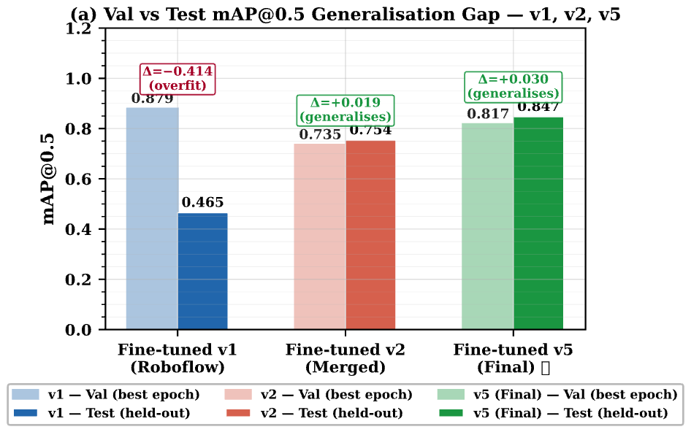

Fine-tuned v1 exhibits a 0.414-point gap between its best validation mAP
(0.879) and held-out test mAP (0.465), a clear sign of distribution overfit
to the single-source Roboflow dataset. Fine-tuned v2 reverses this gap
slightly (+0.019, test marginally beats val), and the final v5 model achieves
positive generalisation (+0.030 gap: test 0.847 > val 0.817), confirming that
the expanded 4,982-image dataset produces a model that generalises robustly
to genuinely unseen real-world imagery.

3. Web UI Pics:

1. User Dashboard

Figure 1. User Dashboard

Figure 2. Narada Voice Section

Figure 3. Narada Chat Section

2. Admin Dasboard

Figure 4.Admin Dashbaord

Figure 5. Email Settings

Figure 6. System Settings (1)

Figure 7. System Settings (2)

Figure 8. Logs Section

Figure 9. Custom Commands Section
Hardware Setup

Ref:
https://www.google.com/url?sa=t&source=web&rct=j&url=https%3A%2F%2Fcommunity.element14.com%2Fproducts%2Fraspberry-pi%2Fb%2Fblog%2Fposts%2Fusing-rpi-camera-module-3-with-rpi5-ai-kit&ved=0CBkQjhxqFwoTCJjApaPV8ZMDFQAAAAAdAAAAABAj&opi=89978449

https://docs.arducam.com/Nvidia-Jetson-Camera/Native-Camera/Quick-Start-Guide/#12mp-imx708-camera

